IMPLEMENTATION OF SYSTEM CALL

Name: Aditya Matale

Roll. No: 25

Div: AIDS (B) – Batch1

__________________________________________________________________________________

File system calls are a subset of system calls in an operating system that provide an interface for user-level programs to interact with the file system. These calls allow programs to perform various operations related to file and directory management, including creating, reading, writing, deleting, and manipulating files and directories. File system calls are essential for managing data stored on storage devices like hard drives, SSDs, and network file systems.

Here are some common file system calls:

* **open()**: Opens a file for reading, writing, or both, and returns a file descriptor that can be used   
   for subsequent operations on the file.
* **read()**: Reads data from an open file into a buffer provided by the calling program.
* **write()**: Writes data from a buffer to an open file.
* **lseek()**: Sets the current position (offset) within a file, allowing for random access reads and   
   writes.
* **dup()**: Typically takes one argument, which is the file descriptor that you want to duplicate. It   
   returns a new file descriptor, which is the lowest-numbered available descriptor.

__________________________________________________________________________________

**I] read() / write() –**

TERMINAL:

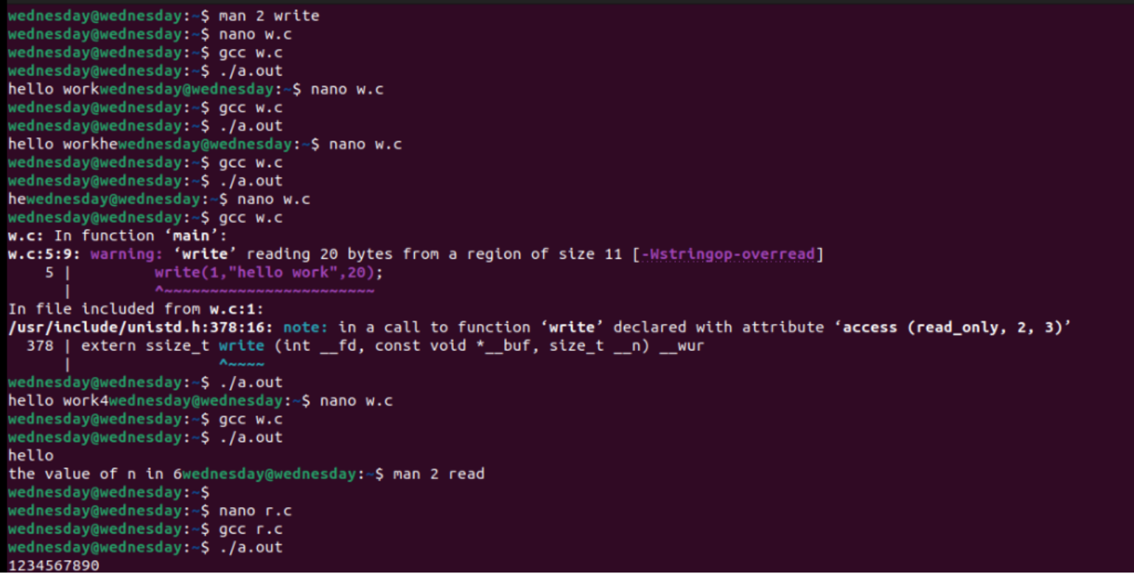

CODE:

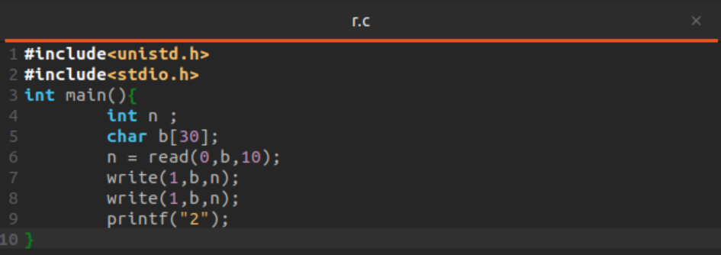

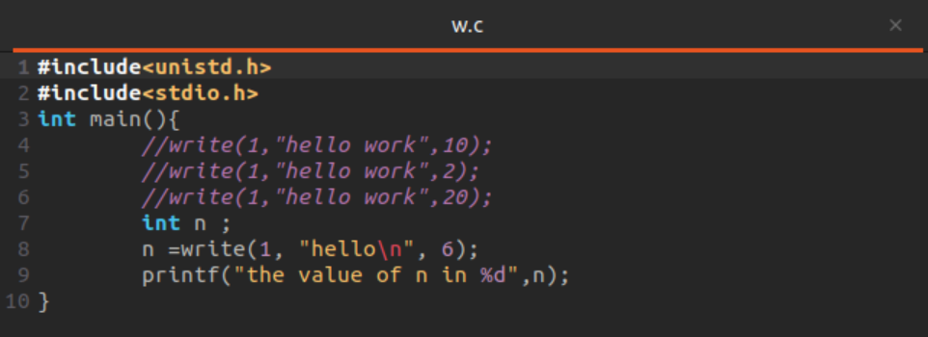

__________________________________________________________________________________

**II] open() –**

TERMINAL:

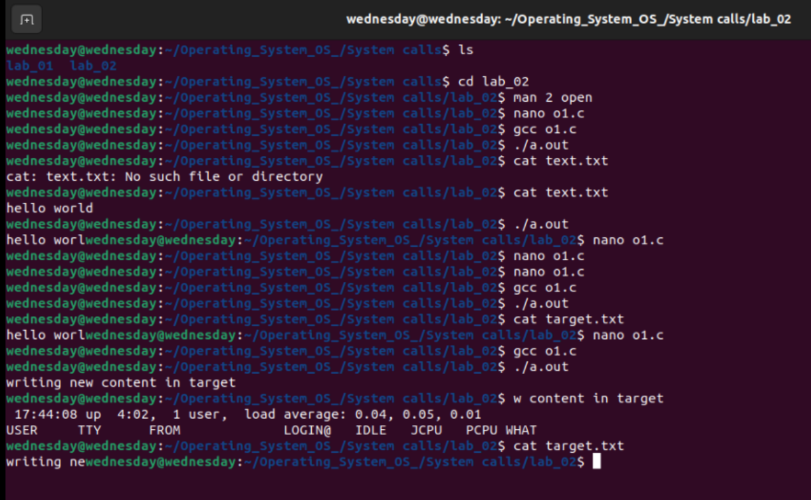

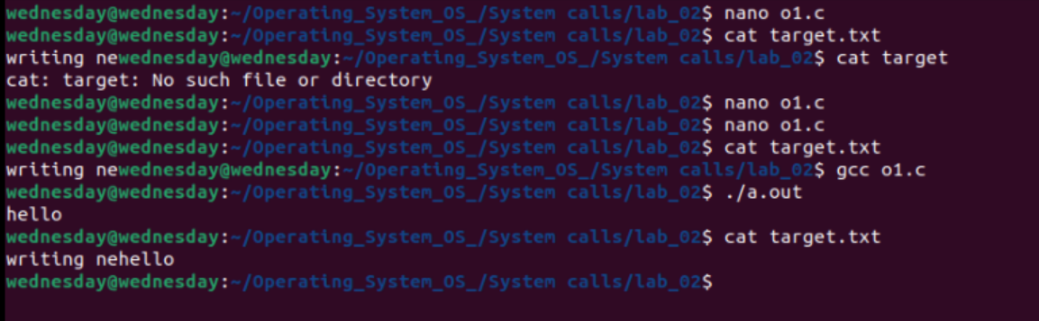

CODE:

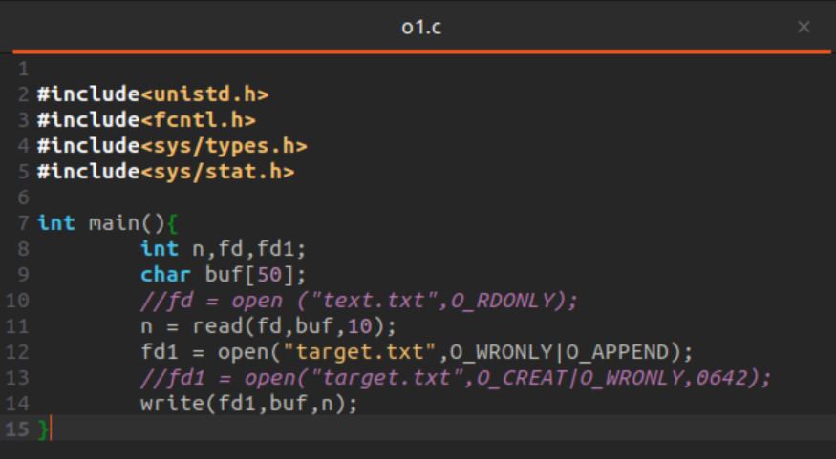

__________________________________________________________________________________

**III] lseek() –**

TERMINAL:

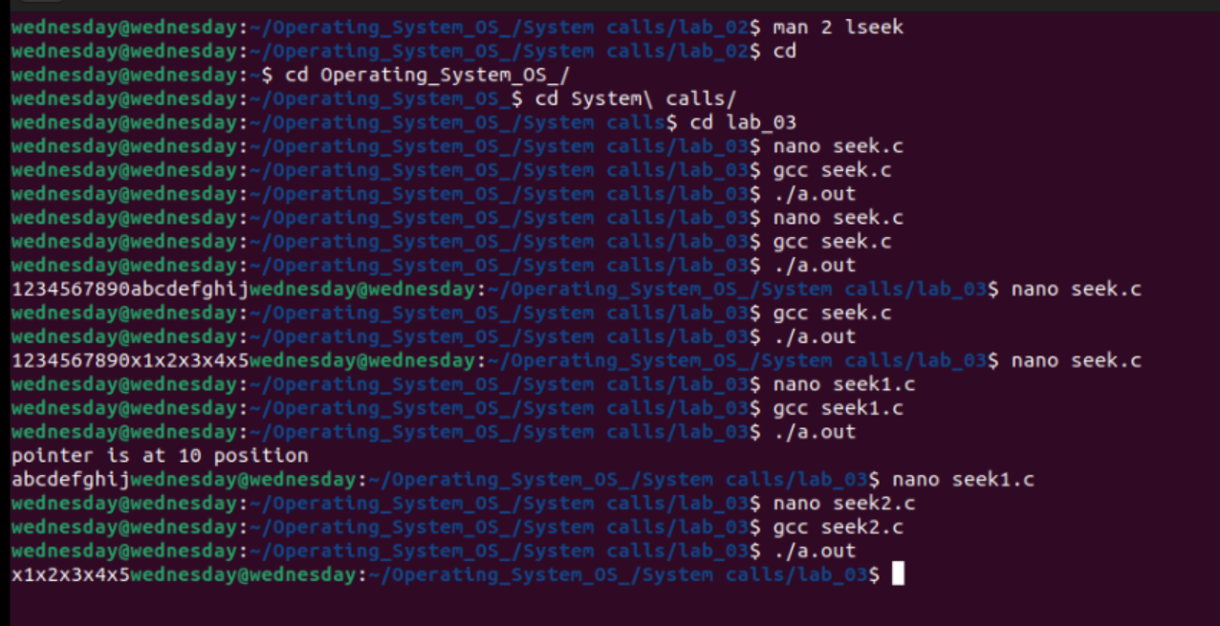

CODE:

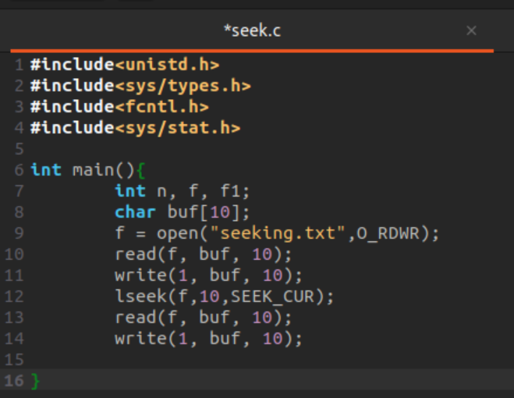

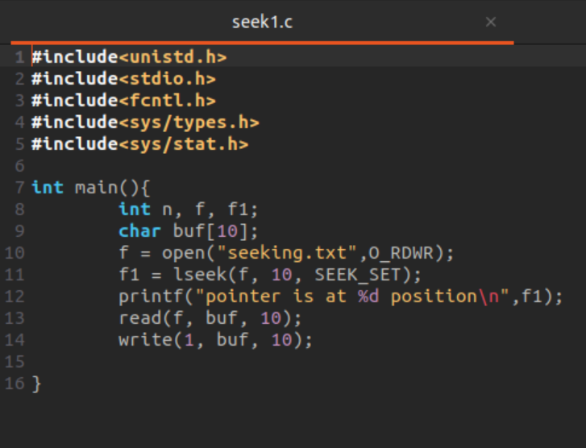

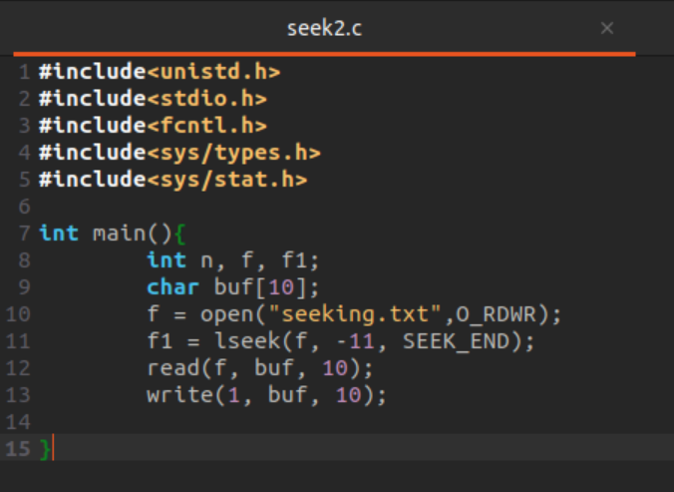

**IV] dup() –**

TERMINAL:

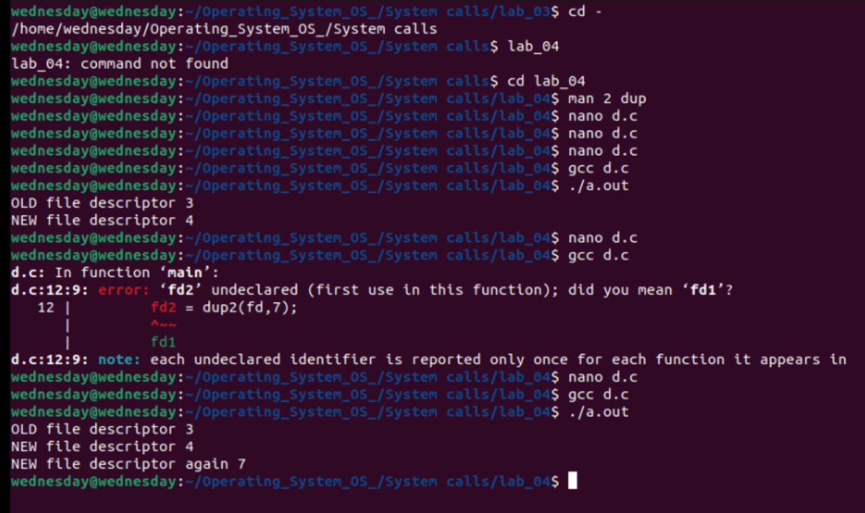

CODE:



